IoT Water Tank Monitoring System with ML Integration
College Research Affiliate Program 2026

A.V. Sudhiksha 23AG1A7204 avsudhiksha@gmail.com ACE Engineering College

- Database Connection

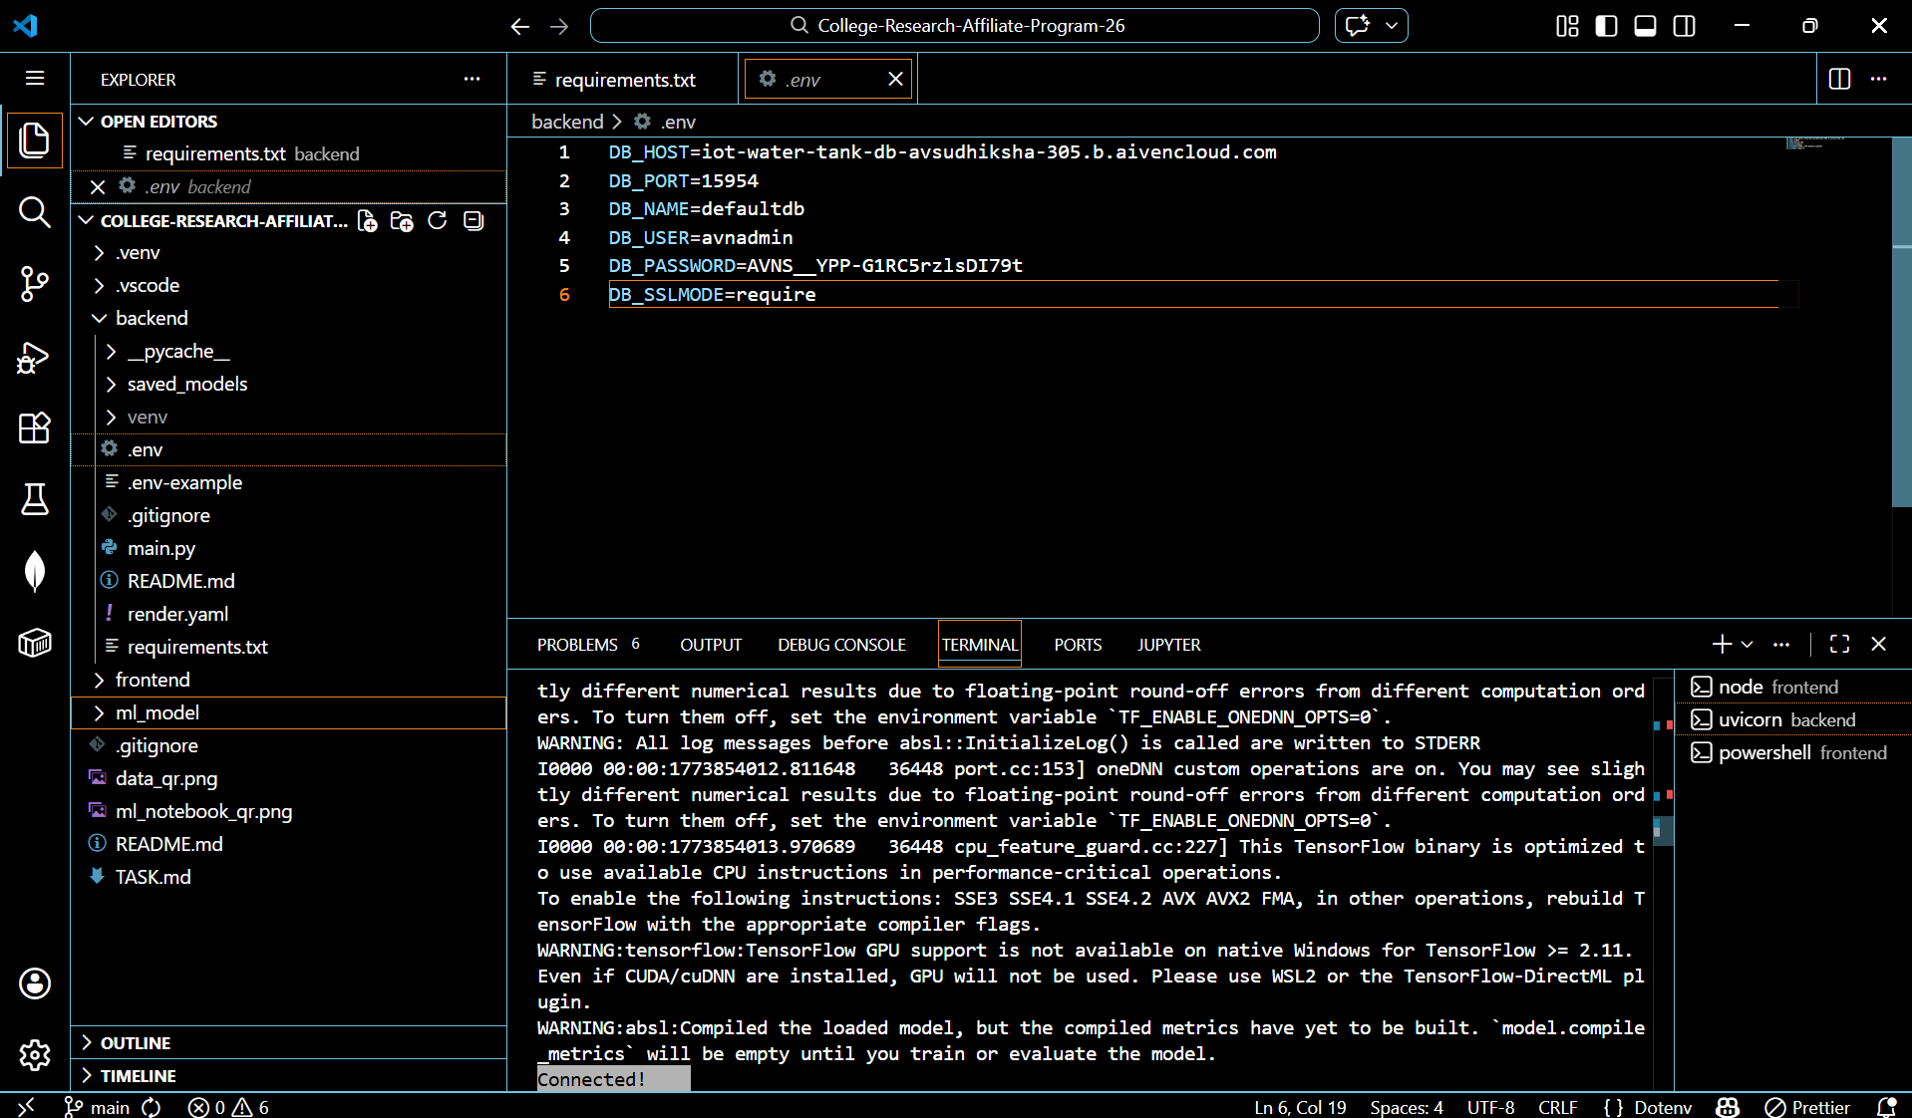

- Working Prediction API

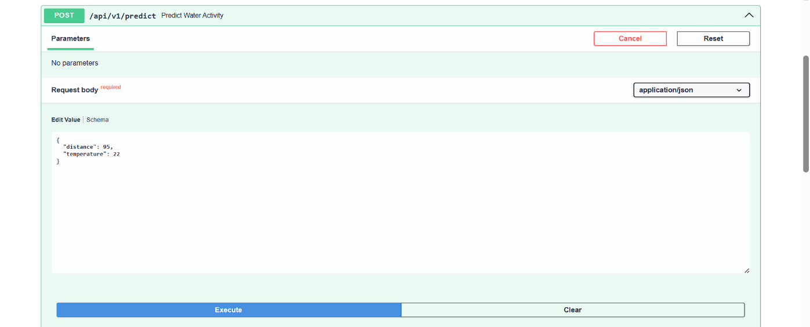
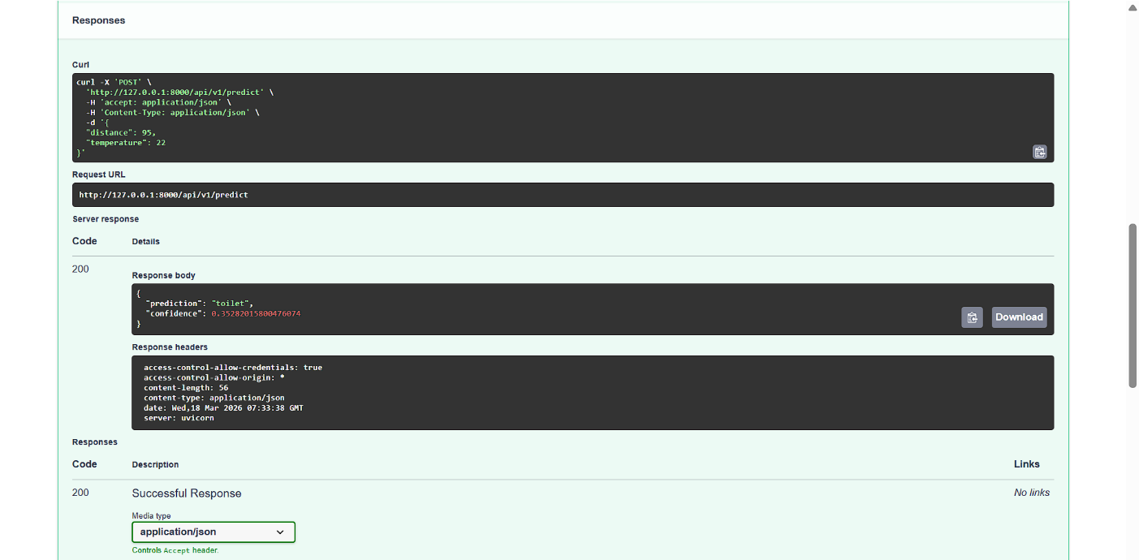

- Working Model Info API

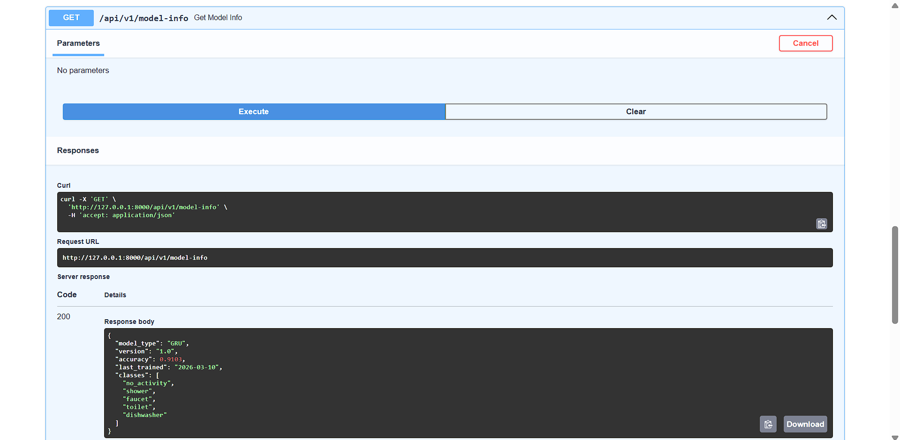

- Code snippet of my prediction implementation

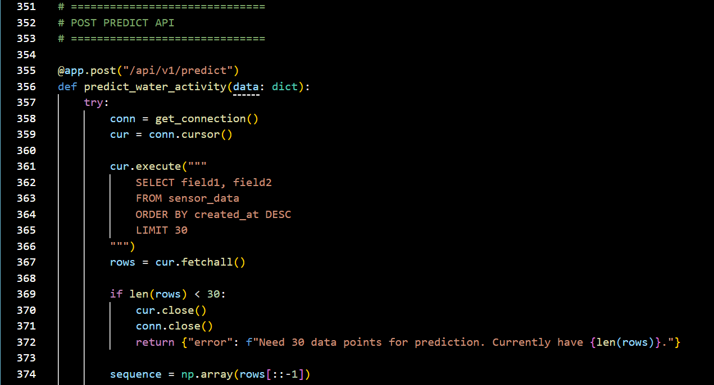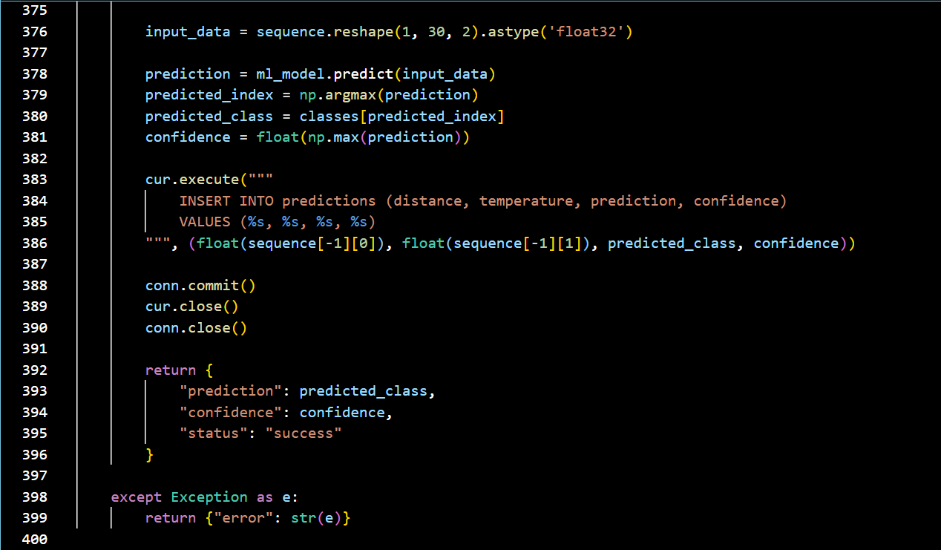

- Training Log Table

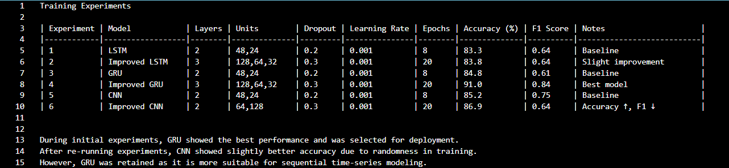

- Training accuracy/loss curves

  - LSTM Model

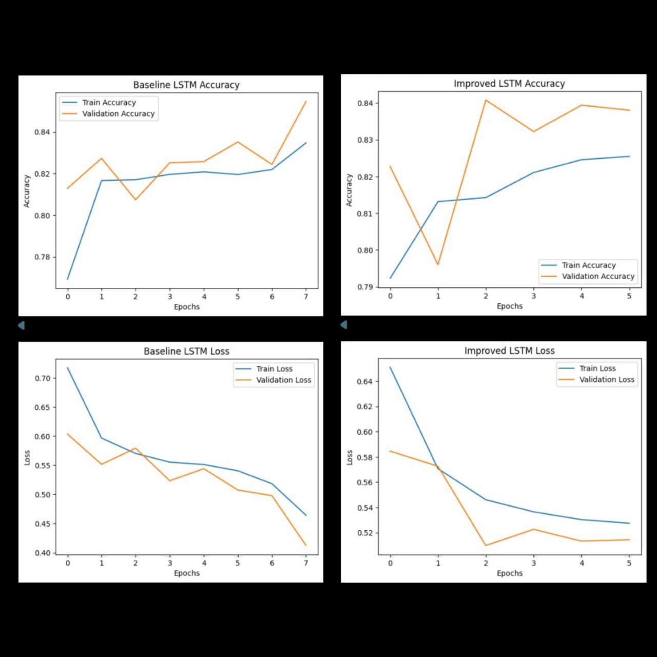

  - GRU Model

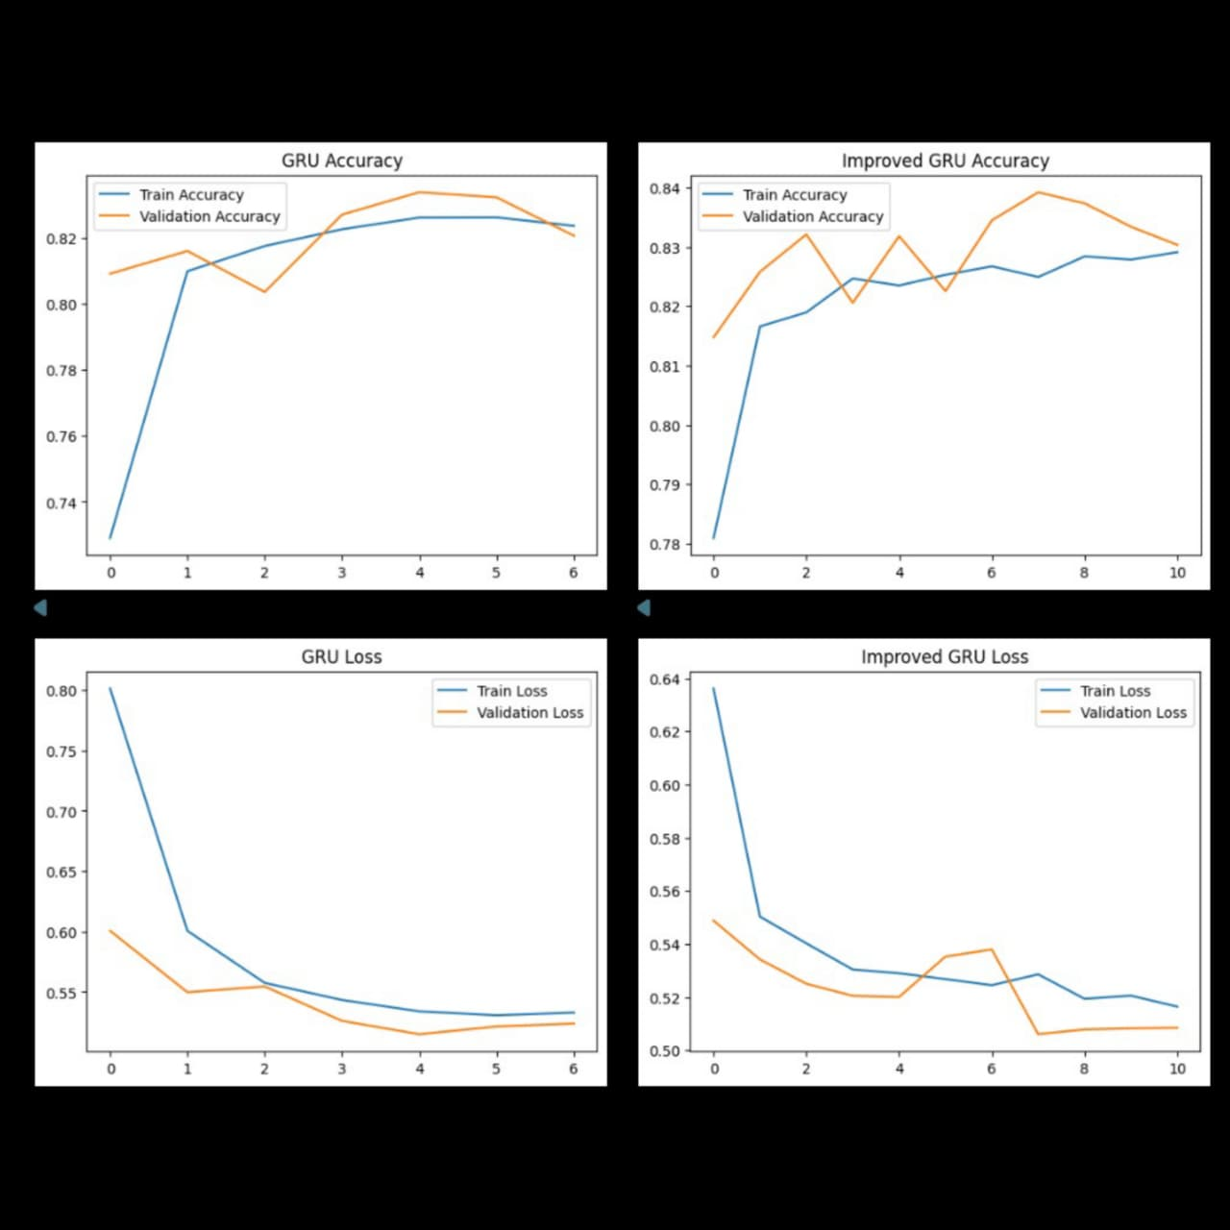

  - CNN Model



- Final model accuracy

Used GRU Model:

Baseline Model Accuracy: 84.8%

Improved Model Accuracy: 91.03%

Accuracy Improvement: +7%

The deep learning model (GRU) significantly outperformed traditional ML models by capturing temporal patterns in water usage data.

- Dashboard with College Logo and Colors

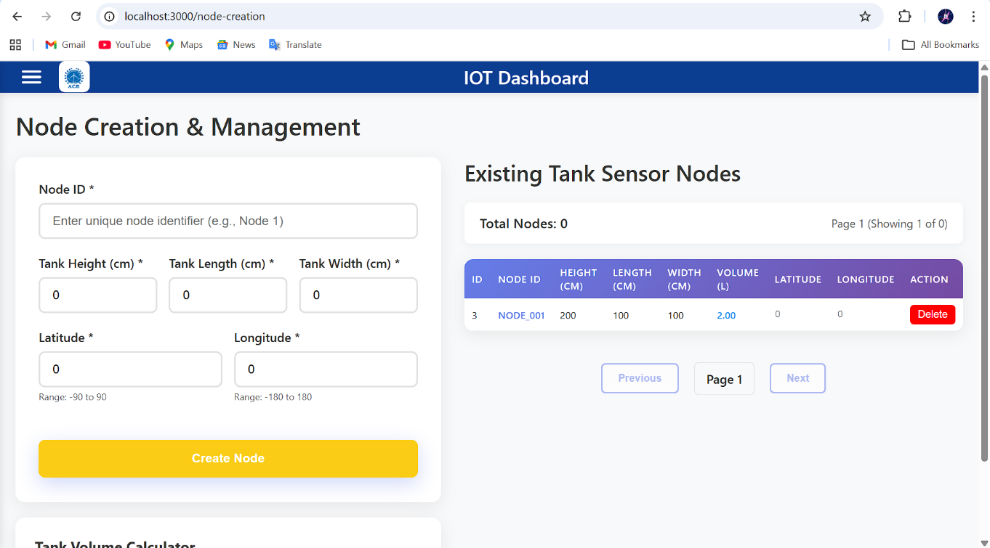

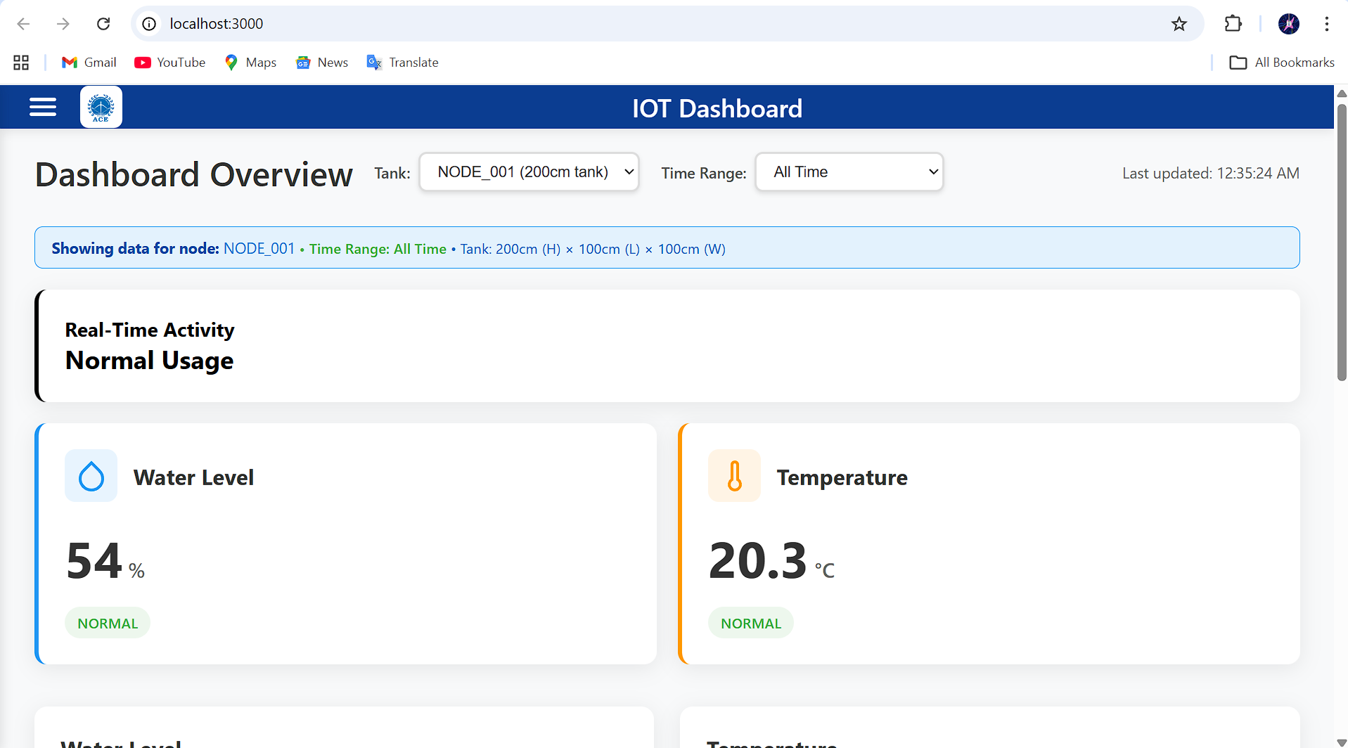

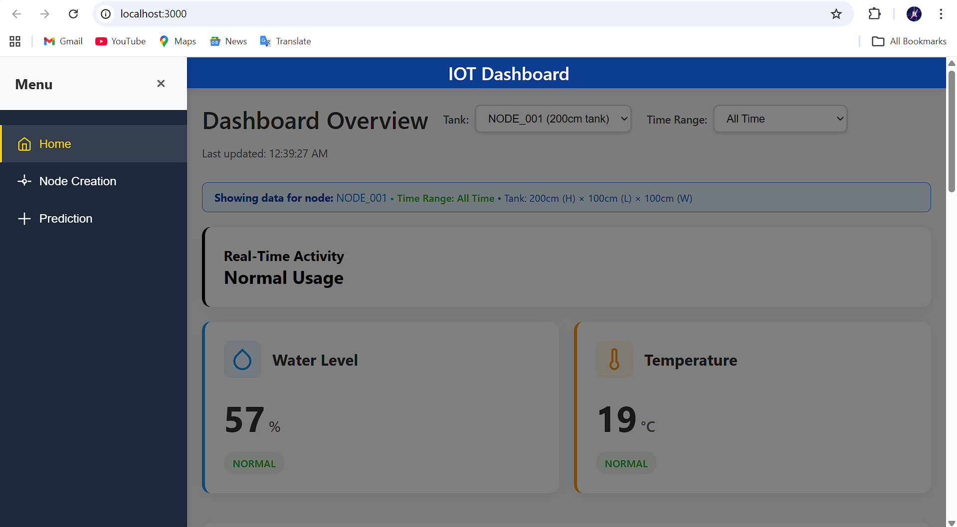

- Prediction page with working predictions

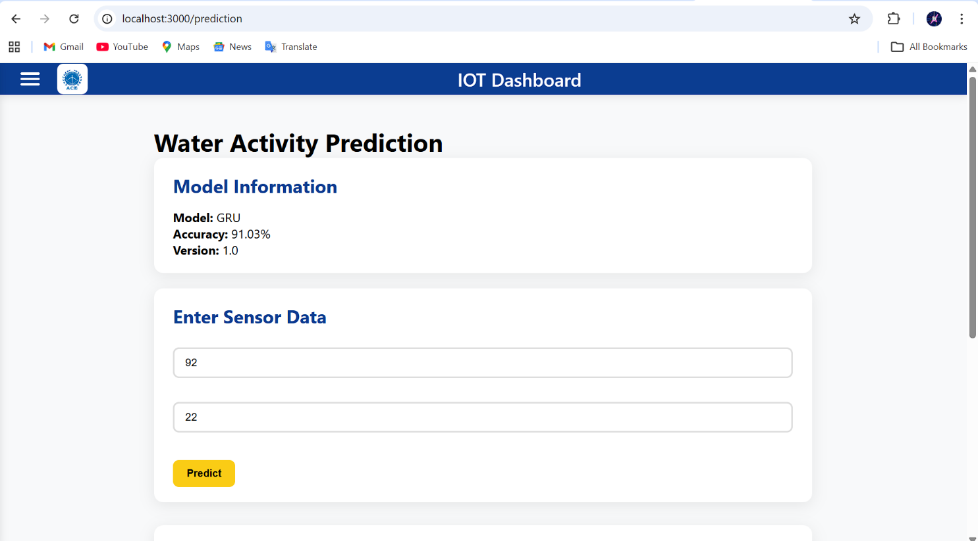

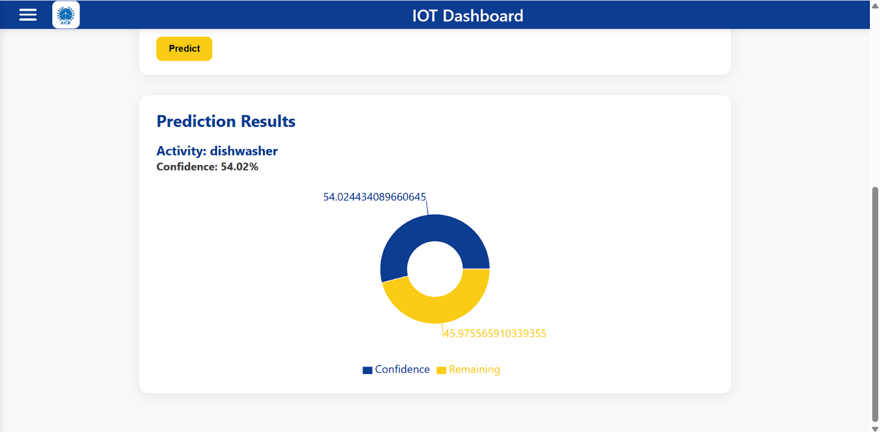

- New custom charts

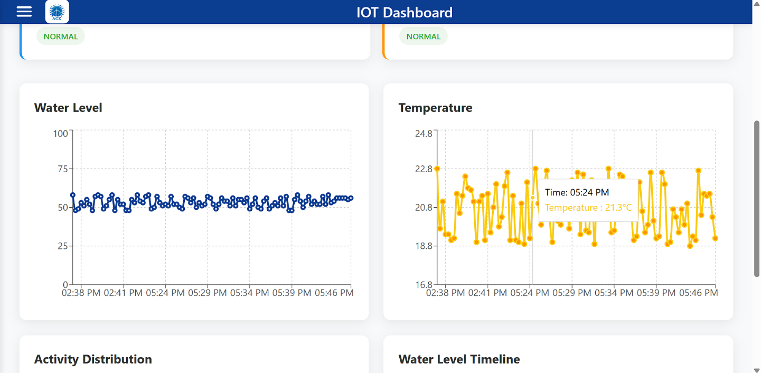

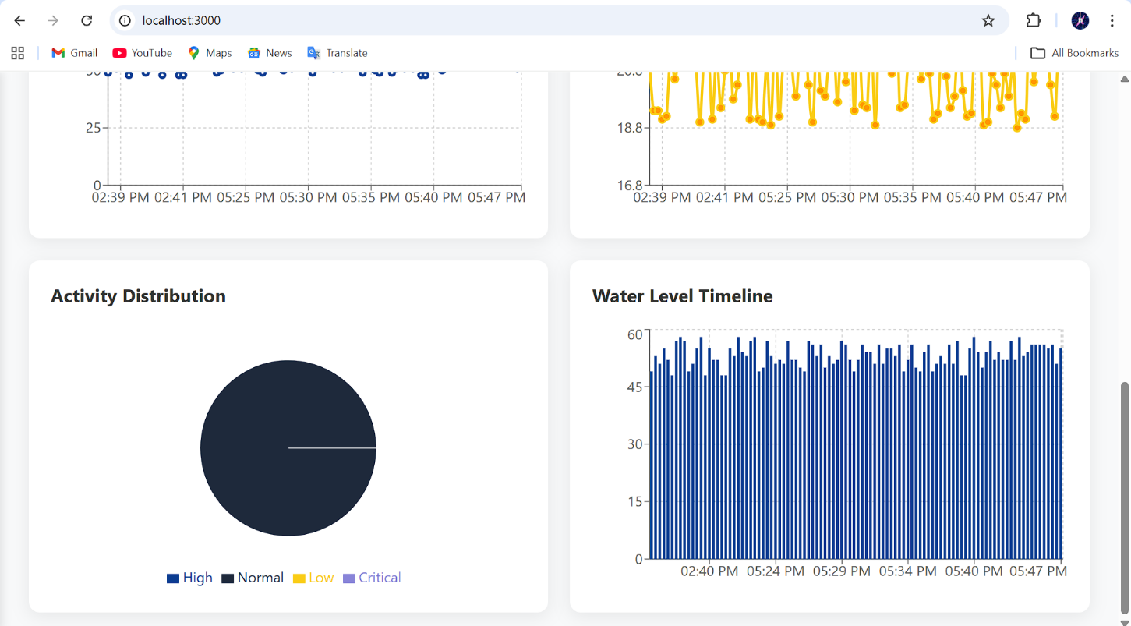
- Code snippets of key modifications

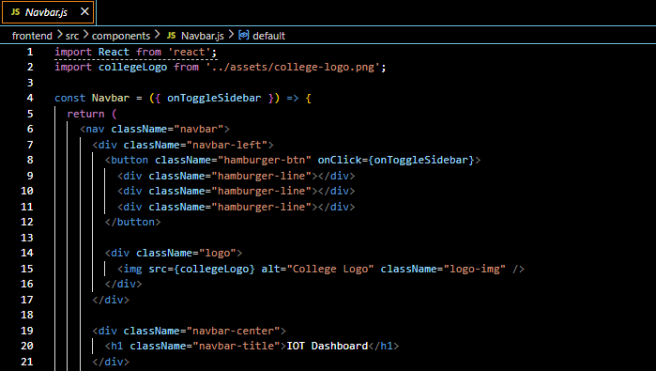

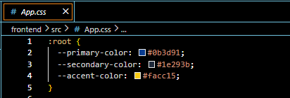

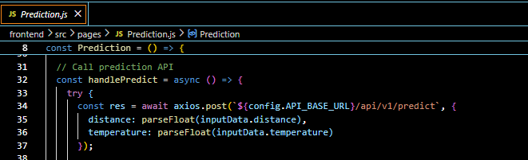
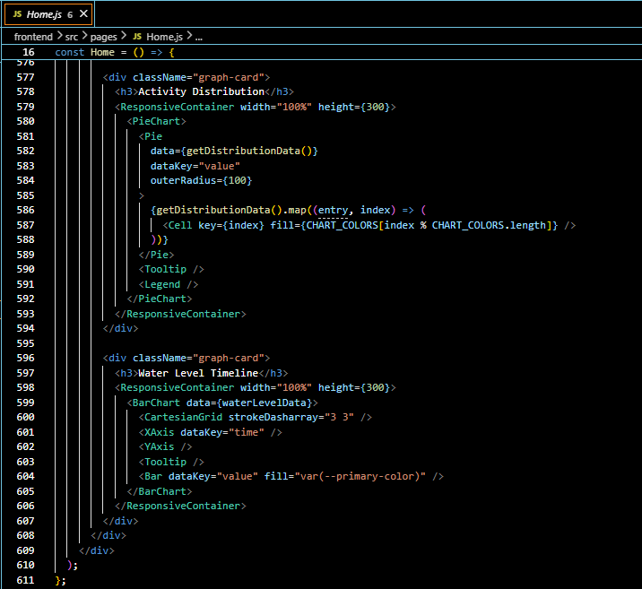

- URLs

  - Deployed backend URL: https://iot-water-tank-api.onrender.com
  - Deployed frontend URL: https://iot-water-tank-sudhiksha-avs-projects.vercel.app/
  - GitHub URL: https://github.com/sudhiksha-av/College-Research-Affiliate-Program-26.git

- Working deployed application

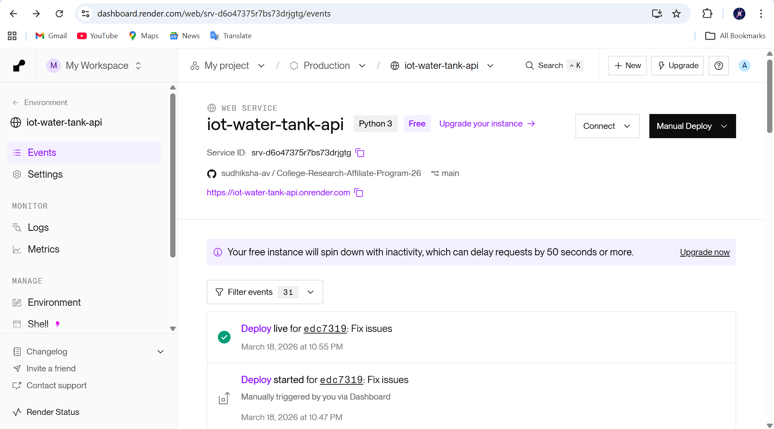

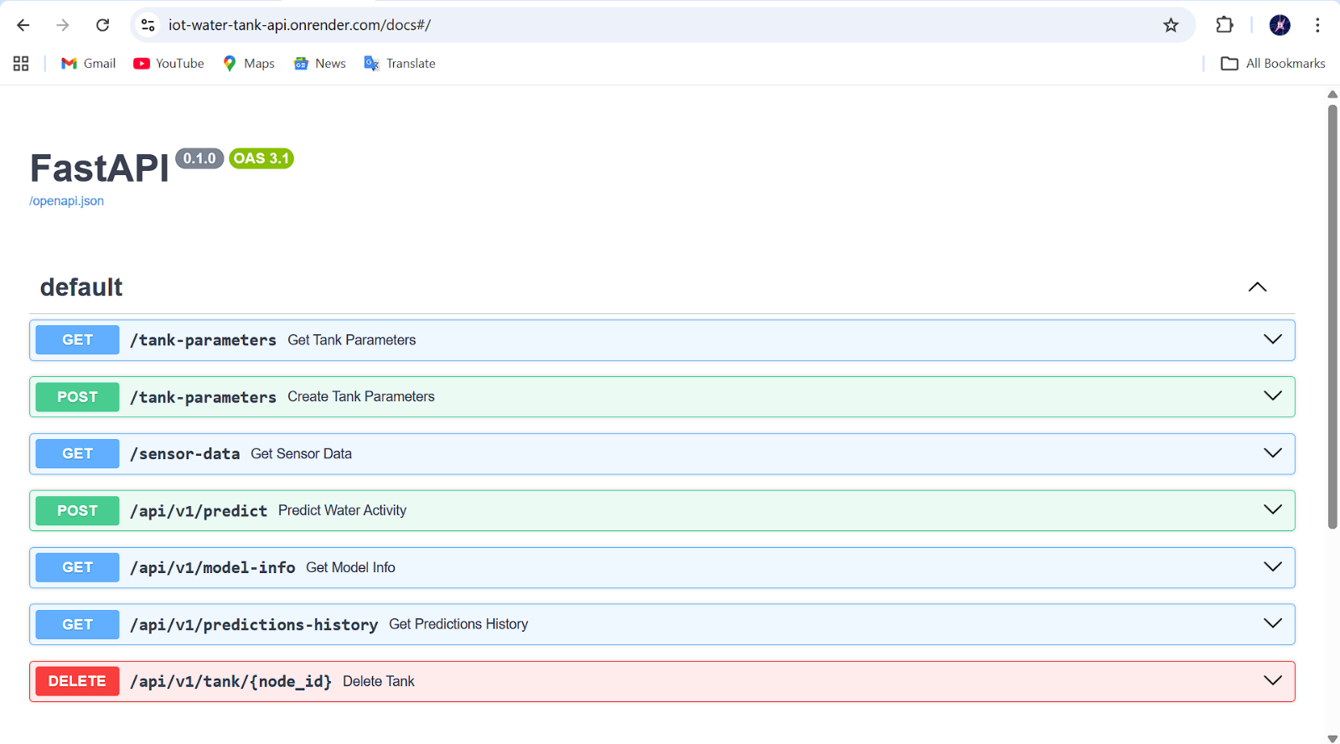

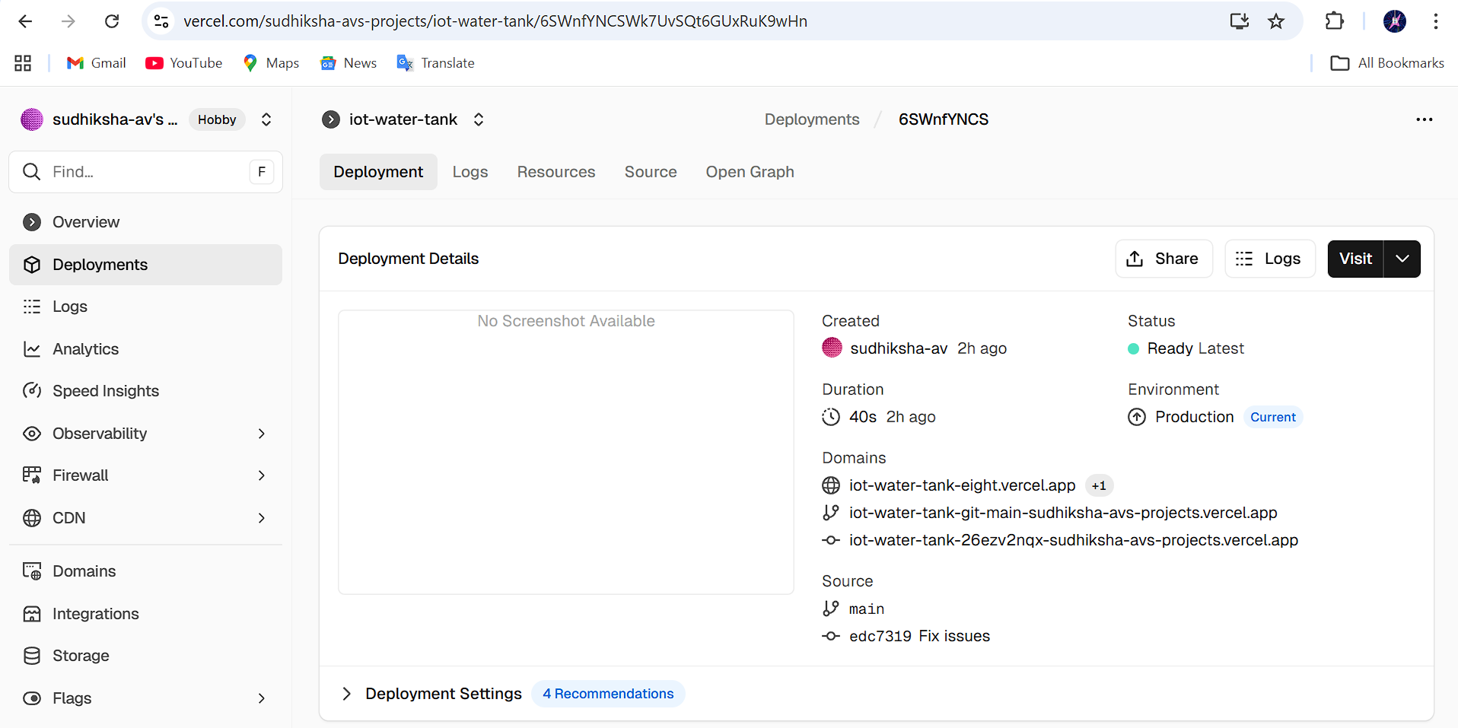

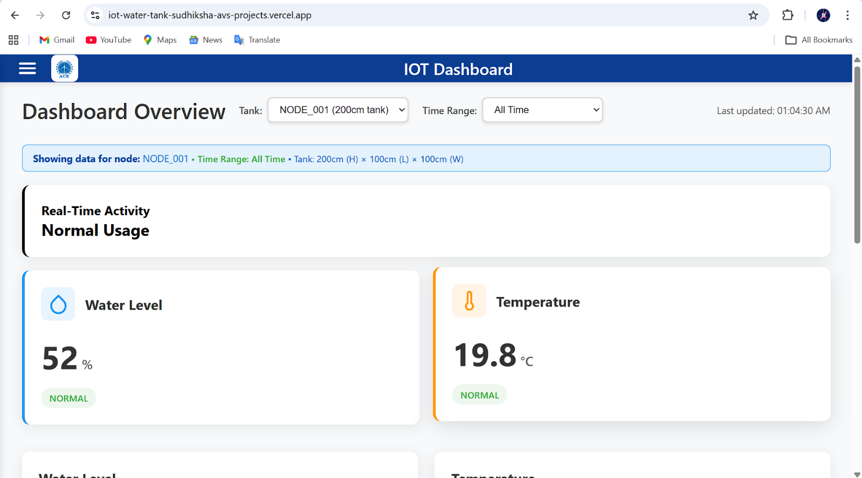

- Prediction working on deployed app

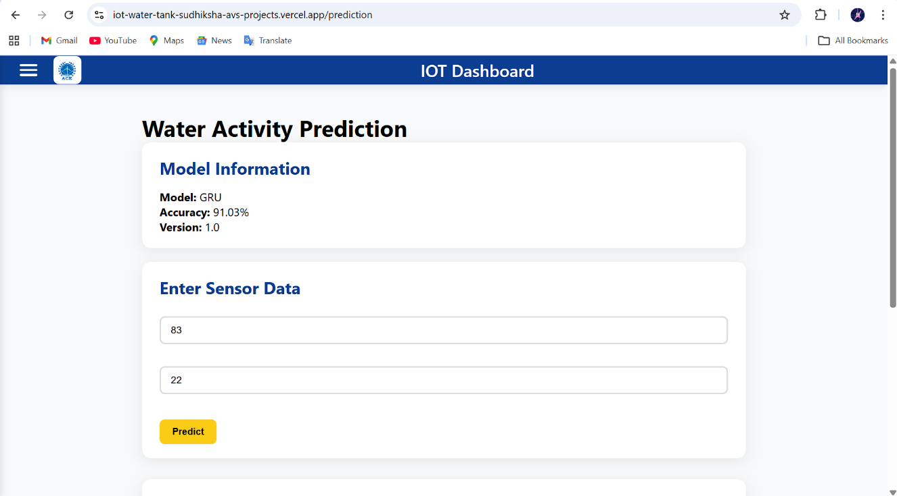

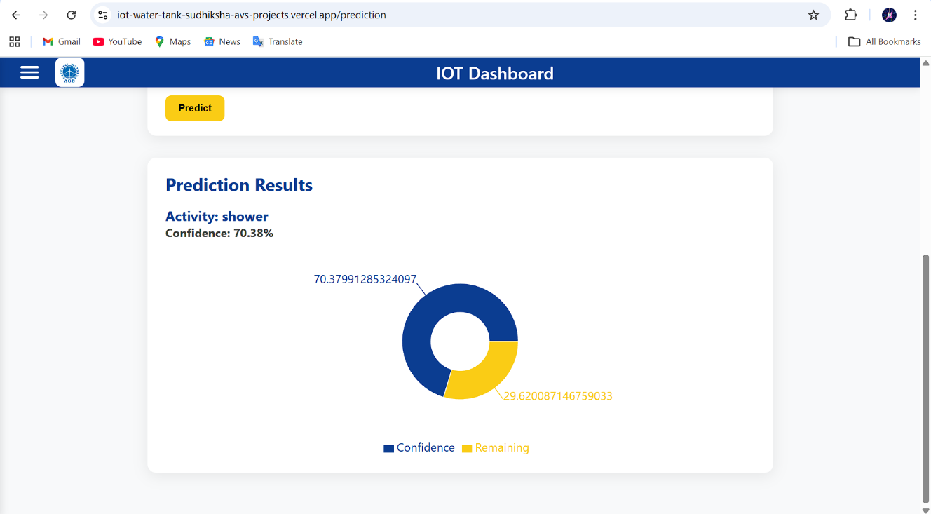

- ML Improvements Made and Accuracy Achieved

In this project, multiple deep learning models were developed and improved to predict water usage activities based on sensor data (distance and temperature).

Baseline Models Implemented:
- LSTM
- GRU
- CNN
Improvements Applied:
- Increased number of units in layers
- Added multiple hidden layers
- Introduced Dropout layers for regularization
- Tuned learning rate and optimizer
- Improved architecture depth (especially GRU)

Final Results:
Model | Accuracy (%) | F1 Score
LSTM | 83.33% | 0.640
Improved LSTM | 83.80% | 0.644
GRU | 84.87% | 0.619
Improved GRU | 91.03% | 0.845
CNN | 85.29% | 0.759
Improved CNN | 86.98% | 0.644

Final Selection:
The Improved GRU model was selected as the best-performing model with:
- Highest accuracy: 91.03%
- Best generalization (F1 score)

- API Endpoints added

API | Method | Description
/predict | POST | Predict water activity
/model-info | GET | Get model details
/predictions-history | GET | View past predictions
/tank/{node_id} | DELETE | Delete a tank

- Frontend Features Added

The frontend was built using React.js with a modern dashboard UI.

UI Enhancements:
- Added college branding (ACE Engineering College)
- Custom color theme using CSS variables
- Integrated college logo in Navbar

Dashboard Features:
- Real-time water level and temperature display
- Interactive line charts using Recharts
- Node (tank) selection dropdown
- Added delete option in nodes table
- Time range filtering (1h, 6h, 24h, custom)

Prediction Page Features:
- Input form for sensor values
- API integration for predictions
- Display of predicted activity
- Confidence Pie Chart visualization
- Centered and styled chart for better UI

Additional Enhancements:
- Added animations to charts
- Improved responsiveness
- Better data handling for no-data cases

- Challenges Faced and Solutions

  - TensorFlow Deployment Issues
Problem:
- TensorFlow was not compatible with latest Python versions on Render
- Model loading errors (quantization_config, batch_shape)
Solution:
- Used version TensorFlow 2.21
- Retrained model using compatible version
- Saved model in .h5 format

  - Dependency Conflicts
Problem:
- Conflict between TensorFlow and FastAPI dependencies (typing-extensions)
Solution:
- Carefully selected compatible versions
- Cleaned requirements.txt

  - Model Serialization Errors
Problem:
- Model trained in Keras 3 not loading in TensorFlow 2.x
Solution:
- Re-trained model using TensorFlow Keras (v2.21)
- Ensured same environment for training and deployment

  - Frontend Integration Errors
Problem:
- Missing components (Prediction page, logo)
- Routing issues
Solution:
- Created missing files
- Fixed import paths
- Added navigation links

  - No Sensor Data Issue
Problem:
- Selected nodes showing no data
Solution:
- Corrected node-to-tank mapping
- Added fallback handling and messages

  - React Setup Errors
Problem:
- react-scripts not recognized
Solution:
- Installed dependencies using npm install

  - Vercel Build Failures
Problem:
- Frontend deployment failed due to missing environment variables and API URLs
Solution:
- Configured environment variables in Vercel
- Updated API base URLs in frontend config

